SMS System - Verification Module

✅ SMS System – Verification Module
# Source: AI Source: Provided by: [Data Path: Persons Table -> ID Column: 1, Name_En Column: Motasem Essam] -> From: [Chatgpt (GPT‑5 Mini)] on [1/21/2026]
The Verification Module in an SMS system is responsible for validating user identity or actions using codes sent via SMS — often part of authentication or security processes like OTP (One-Time Password), account registration, or password reset.

🔐 What Is It?
# Source: AI Source: Provided by: [Data Path: Persons Table -> ID Column: 1, Name_En Column: Motasem Essam] -> From: [Chatgpt (GPT‑5 Mini)] on [1/21/2026]
A Verification Module uses SMS to:
- Send codes or tokens to users’ mobile numbers.
- Verify that the user entered the correct code.
- Confirm the identity or action before proceeding.

🔁 Key Functions:
# Source: AI Source: Provided by: [Data Path: Persons Table -> ID Column: 1, Name_En Column: Motasem Essam] -> From: [Chatgpt (GPT‑5 Mini)] on [1/21/2026]
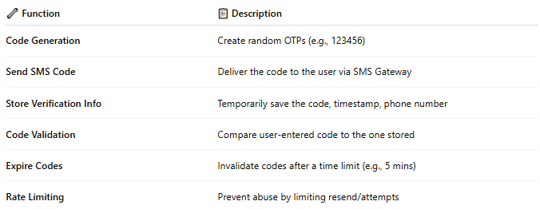

🔧 Function | 📋 Description
Code Generation | Create random OTPs (e.g., 123456)
Send SMS Code | Deliver the code to the user via SMS Gateway
Store Verification Info | Temporarily save the code, timestamp, phone number
Code Validation | Compare user-entered code to the one stored
Expire Codes | Invalidate codes after a time limit (e.g., 5 mins)
Rate Limiting | Prevent abuse by limiting resend/attempts

🗂 Typical Data Stored:
# Source: AI Source: Provided by: [Data Path: Persons Table -> ID Column: 1, Name_En Column: Motasem Essam] -> From: [Chatgpt (GPT‑5 Mini)] on [1/21/2026]
- Phone Number
- OTP Code
- Expiration Time
- Attempt Count
- Status (Pending / Verified / Expired)

🔄 Workflow Example:
# Source: AI Source: Provided by: [Data Path: Persons Table -> ID Column: 1, Name_En Column: Motasem Essam] -> From: [Chatgpt (GPT‑5 Mini)] on [1/21/2026]
- User Action (e.g., sign-up, password reset)
- Verification Module generates a code
- Code is stored temporarily in the database
- Code is sent to user’s phone
- User enters code in the app/web form
- Module validates input against stored code
- On success → verification complete

🛠 Technologies Involved:
# Source: AI Source: Provided by: [Data Path: Persons Table -> ID Column: 1, Name_En Column: Motasem Essam] -> From: [Chatgpt (GPT‑5 Mini)] on [1/21/2026]
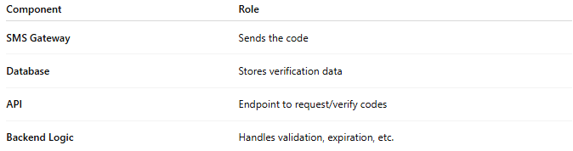

Component | Role
SMS Gateway | Sends the code
Database | Stores verification data
API | Endpoint to request/verify codes
Backend Logic | Handles validation, expiration, etc.

🧠 Example Use Cases:
# Source: AI Source: Provided by: [Data Path: Persons Table -> ID Column: 1, Name_En Column: Motasem Essam] -> From: [Chatgpt (GPT‑5 Mini)] on [1/21/2026]
- Phone number verification during registration
- Two-Factor Authentication (2FA)
- Secure login sessions
- Transaction approval (e.g., banking)

